Exam 2 Review

1. Chart, bar chart, histogram

   Description automatically generated
2. Chart, scatter chart

   Description automatically generated
3. 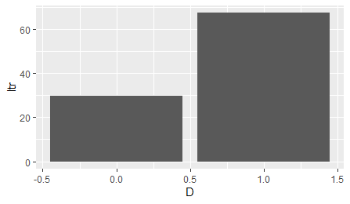
4. D==0 mean of x = 29.7561, D==1 mean of x = 67.43518. yes, it does appear that having D==1 helps with test scores.